**NAME SHISHU**

**REG 2020CA089**

**WEEK-1 HTML**

Q1. Basic HTML Tags, Table Tags, List Tags, Image Tags, Forms.

<!DOCTYPE html>

<html lang="en">

<head>

    <meta charset="UTF-8">

    <meta http-equiv="X-UA-Compatible" content="IE=edge">

    <meta name="viewport" content="width=device-width, initial-scale=1.0">

    <link rel="stylesheet" href="https://maxcdn.bootstrapcdn.com/bootstrap/4.5.2/css/bootstrap.min.css">

    <script src="https://ajax.googleapis.com/ajax/libs/jquery/3.5.1/jquery.min.js"></script>

    <script src="https://cdnjs.cloudflare.com/ajax/libs/popper.js/1.16.0/umd/popper.min.js"></script>

    <script src="https://maxcdn.bootstrapcdn.com/bootstrap/4.5.2/js/bootstrap.min.js"></script>

    <title>image list table</title>

</head>

<body>

 <h1>List</h1>

 <ul>

    <li>shishu</li>

    <li>sharma</li>

</ul>

<ol>

    <li>Coffee</li>

    <li>Tea</li>

    <li>Milk</li>

  </ol>

  <dl>

    <dt>Coffee</dt>

    <dd>black hot drink</dd>

    <dt>Milk</dt>

    <dd>white cold drink</dd>

  </dl>

  <h1>table</h1>

  <div class="container">

    <h2>Basic Table</h2>

    <p>The .table class adds basic styling (light padding and horizonlat dividers) to a table:</p>

    <table class="table table-striped table-bordered table-hover table-dark">

        <thead>

        <tr>

            <th>First name</th>

            <th>Last name</th>

            <th>Email</th>

        </tr>

    </thead>

    <tbody>

        <tr>

            <td>shishu</td>

            <td>sharma</td>

            <td>shishus808@gmial.com</td>

        </tr>

        <tr>

            <td>shishu</td>

            <td>sharma</td>

            <td>shishus808@gmial.com</td>

        </tr>

        <tr>

            <td>shishu</td>

            <td>sharma</td>

            <td>shishus808@gmial.com</td>

        </tr>

    </tbody>

</table>

</div>

<div class="container">

    <h2>Basic Table1</h2>

    <p>The .table class adds basic styling (light padding and horizonlat dividers) to a table:</p>

    <table class="table table-striped">

        <thead>

        <tr class="table-primary">

            <th>First name</th>

            <th>Last name</th>

            <th>Email</th>

        </tr>

    </thead>

    <tbody>

        <tr class="table-secondary">

            <td>shishu</td>

            <td>sharma</td>

            <td>shishus808@gmial.com</td>

        </tr>

        <tr class="table-danger">

            <td>shishu</td>

            <td>sharma</td>

            <td>shishus808@gmial.com</td>

        </tr>

        <tr class="table-warning">

            <td>shishu</td>

            <td>sharma</td>

            <td>shishus808@gmial.com</td>

        </tr>

    </tbody>

</table>

</div>

<div class="container">

    <h2>Basic Table2</h2>

    <p>The .table class adds basic styling (light padding and horizonlat dividers) to a table:</p>

    <table class="table table-bordered">

        <thead>

        <tr>

            <th>First name</th>

            <th>Last name</th>

            <th>Email</th>

        </tr>

    </thead>

    <tbody>

        <tr>

            <td>shishu</td>

            <td>sharma</td>

            <td>shishus808@gmial.com</td>

        </tr>

        <tr>

            <td>shishu</td>

            <td>sharma</td>

            <td>shishus808@gmial.com</td>

        </tr>

        <tr>

            <td>shishu</td>

            <td>sharma</td>

            <td>shishus808@gmial.com</td>

        </tr>

    </tbody>

</table>

<div class="container table-responsive">

    <h2>Basic Table3</h2>

    <p>The .table class adds basic styling (light padding and horizonlat dividers) to a table:</p>

    <table class="table table-hover">

        <thead>

        <tr>

            <th>First name</th>

            <th>Last name</th>

            <th>Email</th>

            <th>sfdjsdlfjl</th>

            <th>sdkfskjdfk</th>

        </tr>

    </thead>

    <tbody>

        <tr>

            <td>shishu</td>

            <td>sharma</td>

            <td>shishus808@gmial.com</td>

        </tr>

        <tr>

            <td>shishu</td>

            <td>sharma</td>

            <td>shishus808@gmial.com</td>

        </tr>

        <tr>

            <td>shishu</td>

            <td>sharma</td>

            <td>shishus808@gmial.com</td>

        </tr>

    </tbody>

</table>

</div>

</div>

<h1>Image</h1>

<div class="row">

    <div class="col-sm-3 col-md-6">

    <img src="c10th.jpg" class="rounded-circle" alt="Cinque Terre">

    <img src="c10th.jpg" class="img-thumbnail img-fluid" alt="Cinque Terre">

</div>

<div class="col-sm-9 col-md-6">

    <img src="c10th.jpg" class="float-left img-fluid" alt="Cinque Terre">

    <img src="c10th.jpg" class="float-right img-fluid" alt="Cinque Terre">

</div>

</div>

<div>

    <a href="https://www.google.com">dkjfl;skd;flk;</a>

    <img src="c10th.jpg" class="mx-auto d-block">

</div>

<div>

    <p>The .img-fluid class makes the image scale nicely to the parent element (resize the browser window to see the effect):</p>

    <img src="c10th.jpg" class="img-fluid" alt="Cinque Terre"> </div>

    <ul class="pagination">

<li class="page-item"><a class="page-link" href="#">Previous</a></li>

<li class="page-item"><a class="page-link" href="#">1</a></li>

<li class="page-item"><a class="page-link" href="#">2</a></li>

<li class="page-item"><a class="page-link" href="#">3</a></li>

<li class="page-item"><a class="page-link" href="#">Next</a></li>

</ul>

</body>

</html>

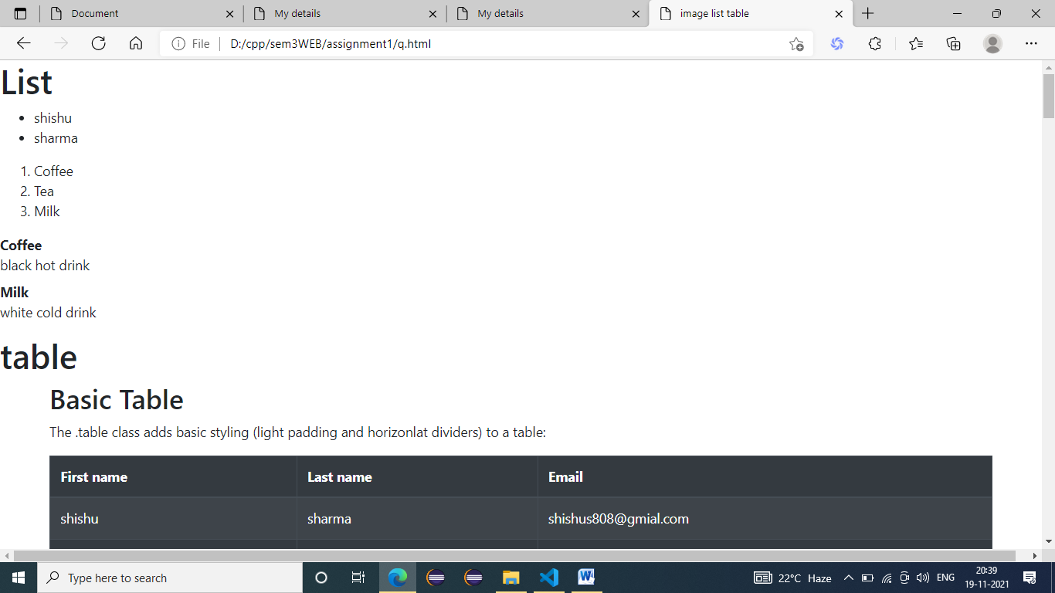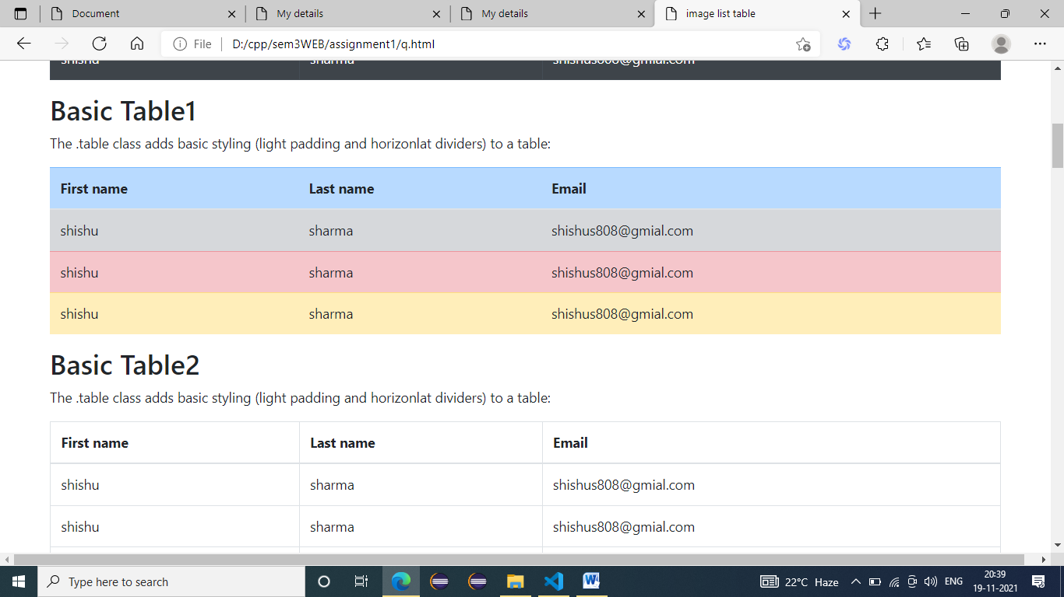

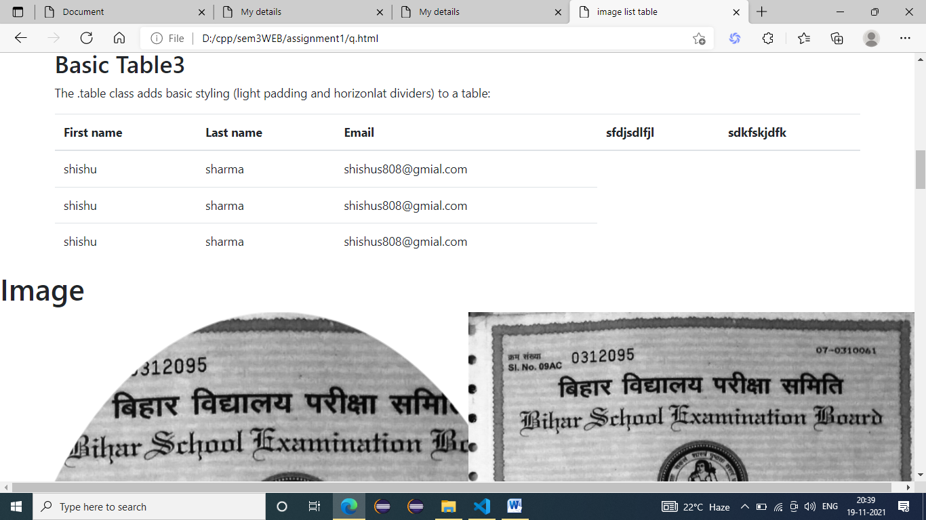

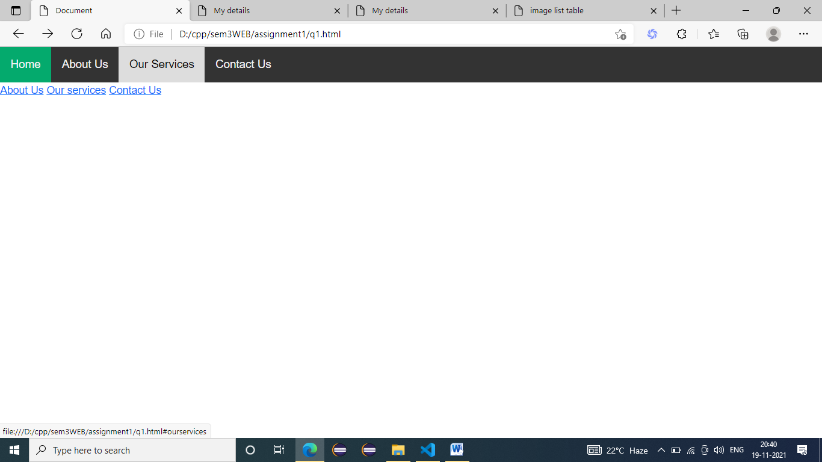

Q2. Write an HTML code to display your education details in a tabular format.

<!DOCTYPE html>

<html lang="en">

<head>

    <meta charset="UTF-8">

    <meta http-equiv="X-UA-Compatible" content="IE=edge">

    <meta name="viewport" content="width=device-width, initial-scale=1.0">

    <link rel="stylesheet" href="https://maxcdn.bootstrapcdn.com/bootstrap/4.5.2/css/bootstrap.min.css">

    <script src="https://ajax.googleapis.com/ajax/libs/jquery/3.5.1/jquery.min.js"></script>

    <script src="https://cdnjs.cloudflare.com/ajax/libs/popper.js/1.16.0/umd/popper.min.js"></script>

    <script src="https://maxcdn.bootstrapcdn.com/bootstrap/4.5.2/js/bootstrap.min.js"></script>

    <title>My details</title>

</head>

<body>

    <table style="display: block;border: 1px;border-color: black;">

        <thead>

          <tr>

            <th>NAME</th>

            <th>SHISHU</th>

          </tr>

        </thead>

        <tbody>

          <tr>

            <td colspan="2">MATRIC</td>

          </tr>

          <tr>

            <td>SCHOOL</td>

            <td>ST. VINOBHA H. SCHOOL</td>

          </tr>

          <tr>

            <td>PERCENTAGE</td>

            <td>71.80</td>

          </tr>

          <tr>

            <td colspan="2">INTERMEDIATE</td>

          </tr>

          <tr>

            <td>COLLEGE</td>

            <td>A.N. COLLEGE PATNA</td>

          </tr>

          <tr>

            <td colspan="2">GRADUATION</td>

          </tr>

          <tr>

            <td>COLLEGE</td>

            <td>A.N. COLLEGE PATNA</td>

          </tr>

          <tr>

            <td colspan="2">M.C.A</td>

          </tr>

          <tr>

            <td colspan="2">PERSUMING</td>

          </tr>

          <tr>

            <td>COLLEGE</td>

            <td>MNNIT ALLAHABAD</td>

          </tr>

          <tr>

            <td></td>

            <td></td>

          </tr>

        </tbody>

        </table>

</body>

</html>

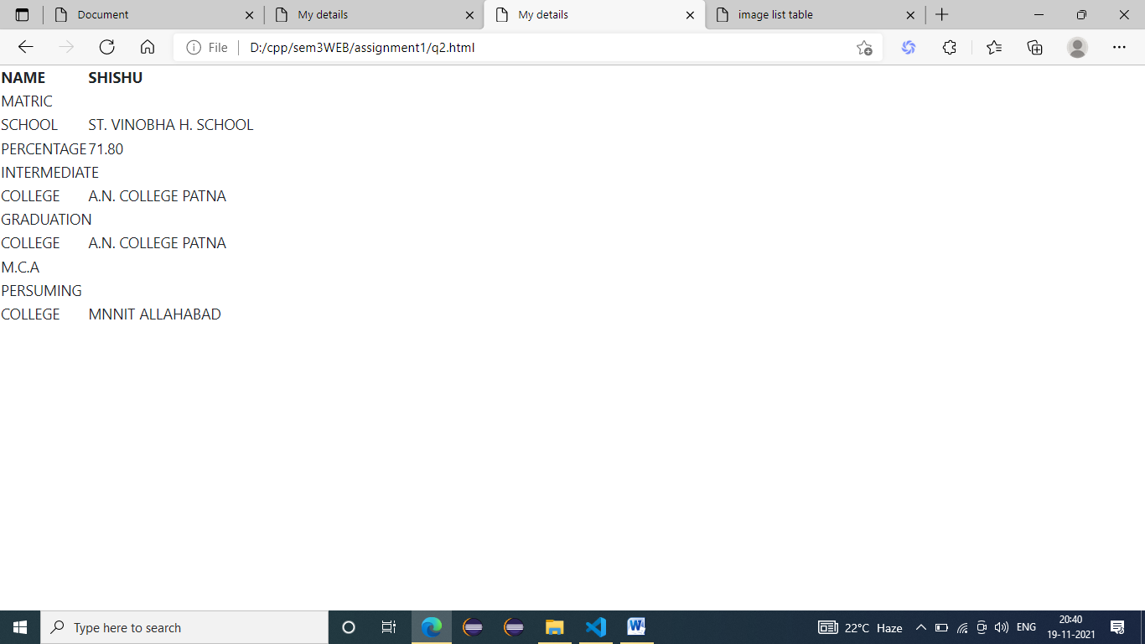

Q3. Write an HTML code to create a Home page having three links: About Us, Our Services and Contact Us. Create separate web pages for the three links.

<!DOCTYPE html>

<html lang="en">

<head>

    <!--BootStrap CSS-->

    <link href="https://cdn.jsdelivr.net/npm/bootstrap@5.1.3/dist/css/bootstrap.min.css" rel="stylesheet"

        integrity="sha384-1BmE4kWBq78iYhFldvKuhfTAU6auU8tT94WrHftjDbrCEXSU1oBoqyl2QvZ6jIW3" crossorigin="anonymous">

        <link rel="stylesheet" href="https://cdnjs.cloudflare.com/ajax/libs/font-awesome/4.7.0/css/font-awesome.min.css">

    <meta charset="UTF-8">

    <meta http-equiv="X-UA-Compatible" content="IE=edge">

    <meta name="viewport" content="width=device-width, initial-scale=1.0">

    <title>Document</title>

    <style>

        body {

            margin: 0;

            font-family: Arial;

        }

        .topnav {

            overflow: hidden;

            background-color: #333;

        }

        .topnav a {

            float: left;

            display: block;

            color: #f2f2f2;

            text-align: center;

            padding: 14px 16px;

            text-decoration: none;

            font-size: 17px;

        }

        .active {

            background-color: #04AA6D;

            color: white;

        }

        .topnav .icon {

            display: none;

        }

        .topnav a:hover {

            background-color: #ddd;

            color: black;

        }

        @media screen and(max-width:600px) {

            .topnav.responsive {

                position: relative;

            }

            .topnav.responsive .icon {

                position: absolute;

                right: 0;

                top: 0;

            }

            .topnav.responsive a {

                float: none;

                display: block;

                text-align: left;

            }

    </style>

</head>

<body>

    <form>

        <div class="topnav" id="myTopnav">

            <a href="#home" class="active">Home</a>

            <a href="#aboutUs">About Us</a>

            <a href="#ourservices">Our Services</a>

            <a href="#contactUs">Contact Us</a>

            <a href="javascript:void(0);" style="font-size:15px" class="icon" onclick="muFunction()">&#9776;</a>

        </div>

        <div>

            <a href="aboutus.html">About Us</a><br>

            <a href="ourservices.html">Our services</a><br>

            <a href="contactus.html">Contact Us</a>

        </div>

    </form>

    <script>

        function myFunction() {

                var x = document.getElementById("myTopnav");

                if (x.className === "topnav") {

                    x.className += " responsive";

                } else {

                    x.className = "topnav";

                }

            }

    </script>

</body>

</html>

